EV CHARGING STATION CONTROLLER USING VERILOG HDL
VLSI Skill Lab Project Report
Submitted by:
Monita Ciea Salins
Department of Electronics and Communication Engineering
Mangalore Institute of Technology and Engineering
Academic Year: 2026–2027

1. Introduction
Electric Vehicles (EVs) have become an important part of modern transportation due to their environmental benefits and lower operating costs. An EV charging station requires a controller that ensures charging begins only under safe and valid conditions.
This project implements an EV Charging Station Controller using Verilog HDL. The controller uses a Moore Finite State Machine (FSM) to manage the charging process by monitoring vehicle connection, authentication, battery status, and disconnection events. The complete design was simulated and synthesized using industry-standard open-source EDA tools.
2. Problem Statement
An EV charging station must ensure that charging occurs only after the vehicle is properly connected and authenticated. Incorrect charging sequences may lead to energy wastage, equipment damage, or unsafe operation.
The controller should:
- Detect vehicle connection.
- Verify authentication.
- Enable charging only after successful authentication.
- Stop charging when the battery becomes fully charged.
- Return to the idle state after charging completion or vehicle disconnection.

3. Existing System
Many basic charging systems rely on manual operation or simple relay control without proper sequencing.
Limitations
- No authentication mechanism.
- Charging may start unintentionally.
- Poor monitoring of charging status.
- Limited safety control.
- Difficult to expand with additional features.
4. Proposed System
The proposed controller is implemented using a Moore FSM.
Features
- Automatic vehicle detection.
- Authentication verification.
- Controlled charging process.
- Battery full detection.
- Safe charging termination.
- Modular RTL implementation.
- Error handling for failed authentication.
5. Objectives
- Design an EV charging controller using Verilog HDL.
- Implement FSM-based charging control.
- Verify the controller through simulation.
- Generate RTL hardware using Yosys.
- Understand complete RTL design flow.

6. System Overview
Inputs:
Signal | Description
Clk | System Clock
Reset | System Reset
vehicle_detect | Detects connected vehicle
auth_success | Authentication status
battery_full | Battery fully charged
disconnect | Vehicle disconnected
Outputs:
Signal | Description
charger_on | Enables charger
charging_done | Charging completed
auth_failed | Authentication failure

7. Working Principle
The controller continuously monitors all input signals.
- System starts in the IDLE state.
- When a vehicle is detected, the controller moves to VEHICLE_DETECTED.
- If authentication succeeds, charging begins.
- During charging, the battery status is monitored.
- Once the battery becomes full, charging stops.
- After the vehicle disconnects, the controller returns to IDLE.
This sequential control ensures safe and reliable charging.

8. Finite State Machine (FSM)
FSM Type : Moore FSM
State | Binary | Description
IDLE | 000 | Waiting for vehicle
VEHICLE_DETECTED | 001 | Vehicle detected
AUTHENTICATION | 010 | Authentication in progress
CHARGING | 011 | Charging enabled
CHARGE_COMPLETE | 100 | Battery fully charged
ERROR_STATE | 101 | Authentication failed
DISCONNECT_STATE | 110 | Vehicle disconnected

9. FSM Diagram
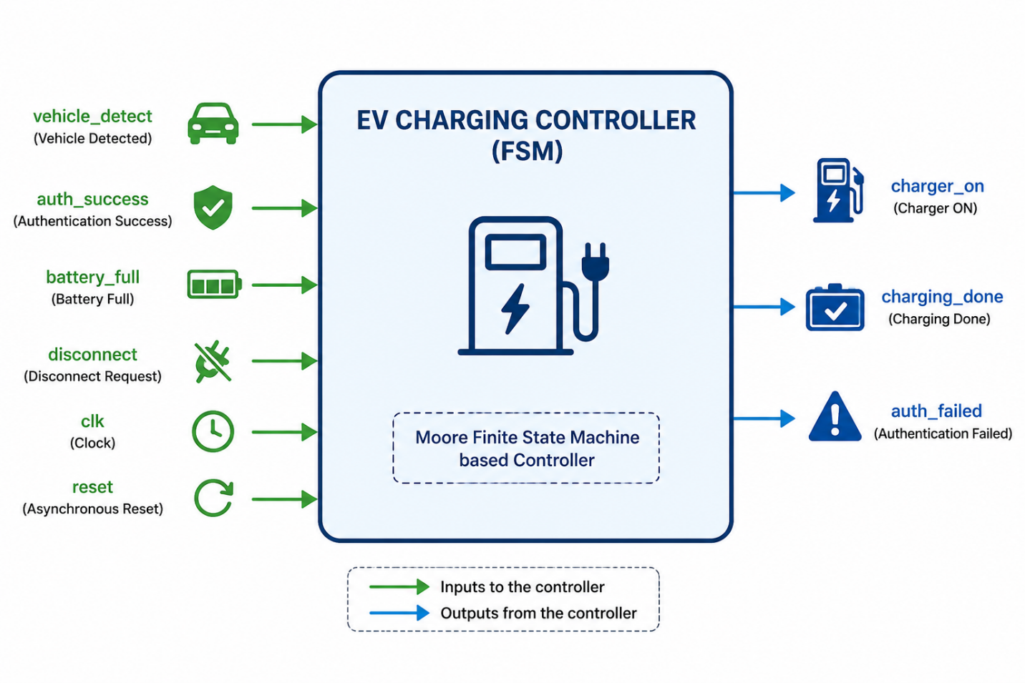
10. State Transition Table
Current State | Condition | Next State
IDLE | vehicle_detect = 1 | VEHICLE_DETECTED
VEHICLE_DETECTED | Automatic | AUTHENTICATION
AUTHENTICATION | auth_success = 1 | CHARGING
AUTHENTICATION | auth_success = 0 | ERROR_STATE
CHARGING | battery_full = 1 | CHARGE_COMPLETE
CHARGE_COMPLETE | disconnect = 1 | DISCONNECT_STATE
ERROR_STATE | disconnect = 1 | IDLE
DISCONNECT_STATE | Automatic | IDLE

11. Circuit Operation
Explain each state:
IDLE
The controller waits until a vehicle is connected.
VEHICLE_DETECTED
The charger detects that a vehicle has been plugged in and waits for successful authentication.
CHARGING
Charging is enabled by activating the charger output.
CHARGE_COMPLETE
Charging is stopped after receiving the battery full signal.
DISCONNECT
After the charging cable is removed, the controller returns to the idle state.
ERROR_STATE
If authentication fails, the controller enters the ERROR_STATE.
Charging remains disabled until the vehicle is disconnected.

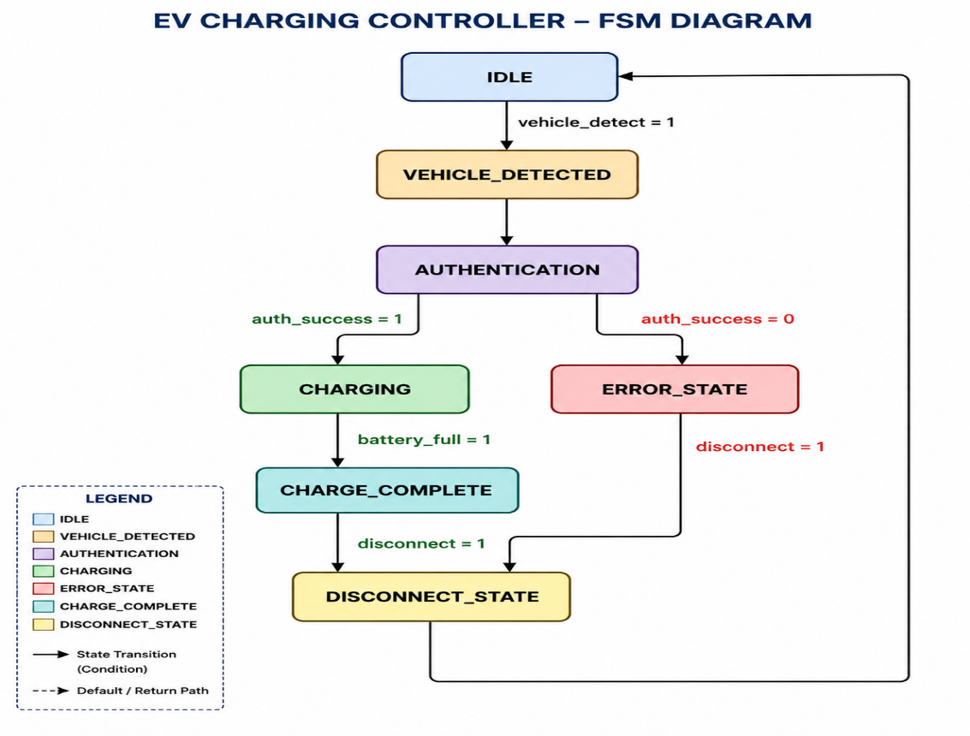
12. Testbench Design
A testbench is used to verify the functionality of the Verilog design by applying different input combinations and observing the corresponding outputs. The testbench is a non-synthesizable module that generates input stimulus for the EV Charging Station Controller.
Waveform Analysis
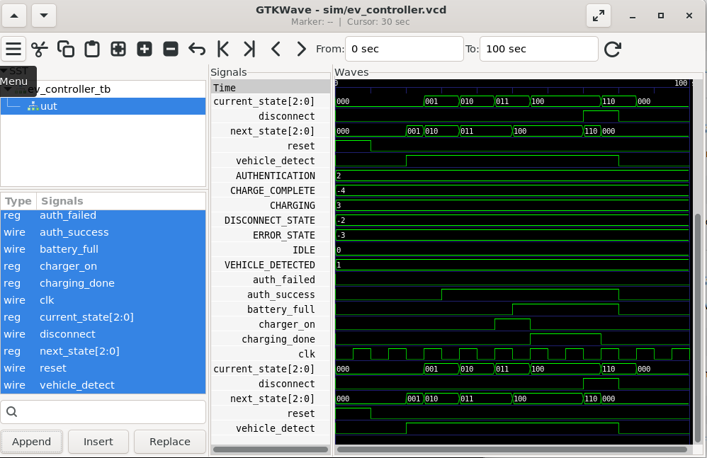
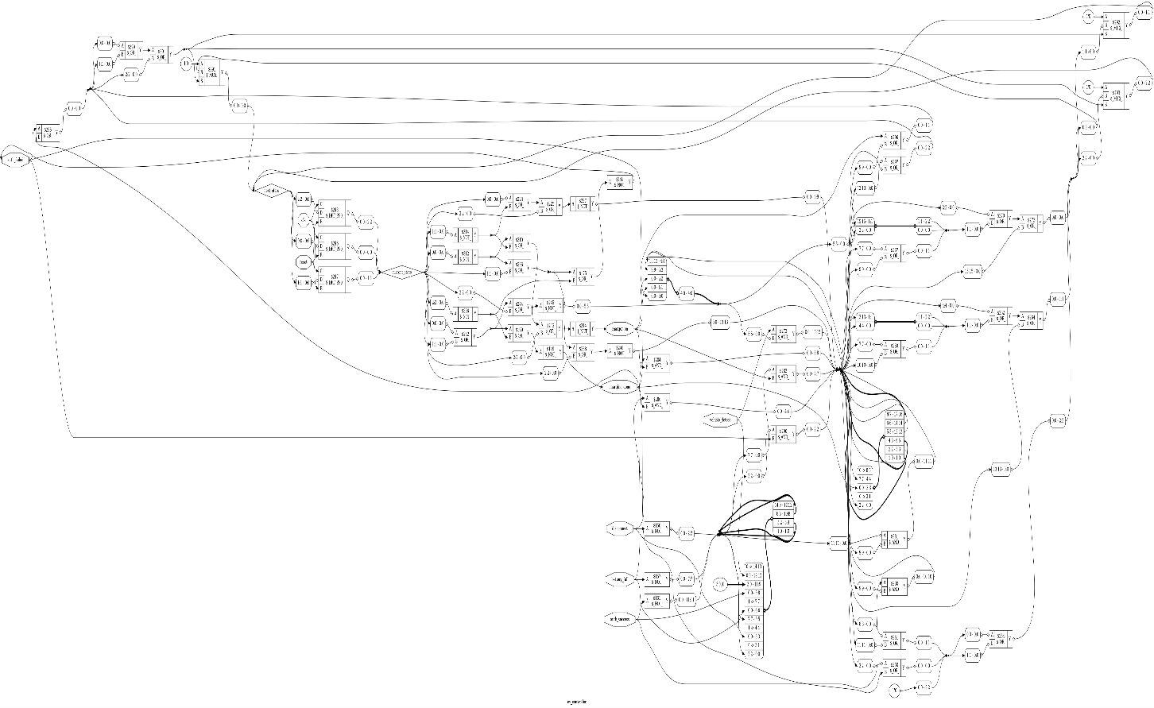
The waveform confirms the correct operation of the controller.
- The clock signal drives all state transitions.
- The reset signal initializes the controller to the IDLE state.
- Vehicle detection changes the controller to the VEHICLE_DETECTED state.
- Successful authentication enables charging.
- The battery full signal disables charging and indicates charging completion.
- Vehicle disconnection returns the controller to the IDLE state.
The waveform verifies that the controller performs all operations according to the designed FSM.

13. RTL Schematic (Yosys)
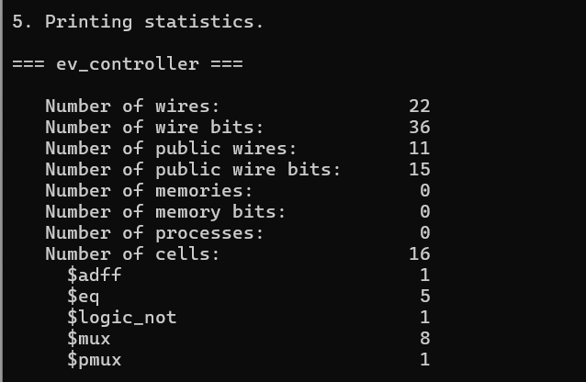
The RTL schematic was generated using Yosys after synthesizing the Verilog design. It illustrates the hardware implementation of the controller, including the FSM logic, state registers, and output control circuitry. The schematic confirms that the Verilog code is successfully synthesized into digital hardware.
Logic Utilization
The design was synthesized using Yosys at the RTL level. The synthesized circuit consists of state registers and combinational logic required for implementing the finite state machine. Since the design was not mapped to a specific FPGA device, FPGA-specific LUT utilization was not generated.
Advantages
- Safe and controlled charging operation.
- Prevents unauthorized charging.
- Simple Moore FSM implementation.
- Easy to simulate and verify.
- Modular and easy to enhance.
Applications
- Public EV charging stations
- Home EV charging systems
- Smart charging infrastructure
- FPGA and VLSI learning projects
- Electric vehicle control systems
Tools Used
- Verilog HDL – Used for designing the RTL of the EV Charging Station Controller.
- Icarus Verilog (iverilog) – Used for compiling the Verilog source code and testbench.
- VVP (Verilog Virtual Processor) – Used to execute the compiled simulation.
- GTKWave – Used to view and analyze the simulation waveform (.vcd file).
- Yosys – Used for RTL synthesis and generation of the RTL schematic.
- Ubuntu (WSL) – Used as the Linux development environment for RTL design and simulation.
- Nano Editor – Used for writing and editing Verilog source files and scripts.
- Git – Used for version control and tracking project changes.
- GitHub – Used to host and manage the project repository.
- Graphviz – Used by Yosys to generate the RTL schematic visualization.
Future Scope
- Add RFID-based authentication for secure user verification.
- Implement fast charging mode with intelligent charging control.
- Integrate UART communication for monitoring and debugging.
- Add CAN bus communication for interaction with electric vehicle systems.
- Implement battery health monitoring and diagnostics.
- Support multiple charging ports for simultaneous EV charging.
- Integrate IoT-based remote monitoring and control.
- Add smart charging algorithms for improved energy efficiency.
- Implement fault detection and protection mechanisms such as overcurrent and overvoltage protection.
- Deploy the design on an FPGA development board for real-time hardware validation.

14. Conclusion
The EV Charging Station Controller was successfully designed using Verilog HDL and implemented using a Moore Finite State Machine. The design was verified through simulation using Icarus Verilog and GTKWave, and the RTL schematic was generated using Yosys. The results confirm that the controller performs safe and reliable charging operations, making it suitable as a basic digital controller for EV charging applications.

